ORDER OF WORSHIP
Our Mission Statement: “Growing together in our knowledge and love of God through Jesus Christ and sharing this with others.”

PRELUDE & ENTRANCE OF THE LIGHT
CHORAL INTROIT “He is Lord” arr Betty Pulkingham
WELCOME & ANNOUNCEMENTS
Welcome! We are glad you’re here. To help us know one another, please sign and pass our Friendship Pad and join us for fellowship at coffee hour following the worship service.
*CALL TO WORSHIP (Excepts from Psalm 25)
To You, O Lord, I lift up my soul.
O my God, in you I trust; do not let me be put to shame; do not let my enemies exult over me.
Make me to know your ways, Oh Lord; teach me your paths.
Lead me in your truth, and teach me, for you are the God of my salvation.
Good and upright is the Lord.
He leads the humble in what is right and teaches the humble his way.
*OPENING HYMN “Come Christians Join to Sing ” #158
LIGHTING THE CANDLES OF REMEMBRANCE & PEACE
The Candle of Remembrance is lit for those in the military and their families, veterans, first responders, and all those in harm’s way. The Candle of Peace reminds us to pray for God’s peace in our homes, community, nation, and the world.
PRAYER OF CONFESSION
Holy and Merciful God, in your presence we confess our sinfulness, our shortcomings, and our offenses against you. You alone know how often we have sinned, in wandering from your ways, in wasting your gifts, in forgetting your love. Have mercy on us, O Lord, for we are ashamed and sorry for all we have done to displease you. Forgive our sins, and help us to live in your light, and walk in your ways, for the sake of Jesus Christ our Savior. Amen.

(Silent Prayer)
HYMN OF REFLECTION “Fill My Cup Lord ” #641
WORDS OF ASSURANCE
In Christ, you are forgiven.
Amen.
*SHARING THE PEACE OF CHRIST
The peace of Christ be with you.
And also with you!
Please greet one another in Christ’s peace.
*GATHERING RESPONSE “Bind Us Together” TFWS#2226
CHOIR ANTHEM “A Lenten Meditation” Douglas Wagner
WORSHIPPING WITH OUR YOUNG DISCIPLES
PASTORAL PRAYER
(Followed by The Lord’s Prayer using “debts” and “debtors.”)
OFFERING OF TITHES AND GIFTS
*SONG OF THANKSGIVING
“Praise God, from Whom All Blessings Flow” #95
PRAYER OF DEDICATION (Unison)
Gracious God, you set Jesus Christ as the Head of the Church to rule over all things on earth, and you have made us servants in your kingdom. Help us to be good stewards of the gifts you have given and make us generous givers of our time and talents. Use our tithes and offerings for your work, helping us to minister to those in need, as we share your gospel light in the world. United in love and in the fellowship of Christ, we pray. Amen.
SCRIPTURE READING Matthew 11:28-30
*HYMN “Jesus, Lover of My Soul” #479
SCRIPTURE READING John 4:5-42
MESSAGE “Come to Me ” Elder Lynn Jacques
*CLOSING HYMN “Come We That Love the Lord” #732
*BENEDICTION
*RESPONSE “Shalom” #666
*POSTLUDE
*stand as you are able

The First United Church of East Syracuse
Church Telephone: 315-463-6833
Church e-mail: esyrchurch@verizon.net
Pastor’s e-mail: revrndeb@gmail.com
www.unitedchurchesyr.org
Pastor: Rev. Debra L. Thomas
Music Director: Christy Knowlton
Worship Assistant: Chuck Provo
Sound & Technology: William Jacques
Nursery Care: Mary Anne Schweitzer
Like us on Facebook
To download our free church app, search for “Church App Tithe.ly” on your phone app store or google play. Click on the blue icon, download, and search for “First United Church of East Syracuse” and open. Allow notifications to receive emergency cancellation notices.
Note: Weather related closing/cancellation of worship services or programs, will be listed on the Channel 9 news scroll.

Welcome to Worship!

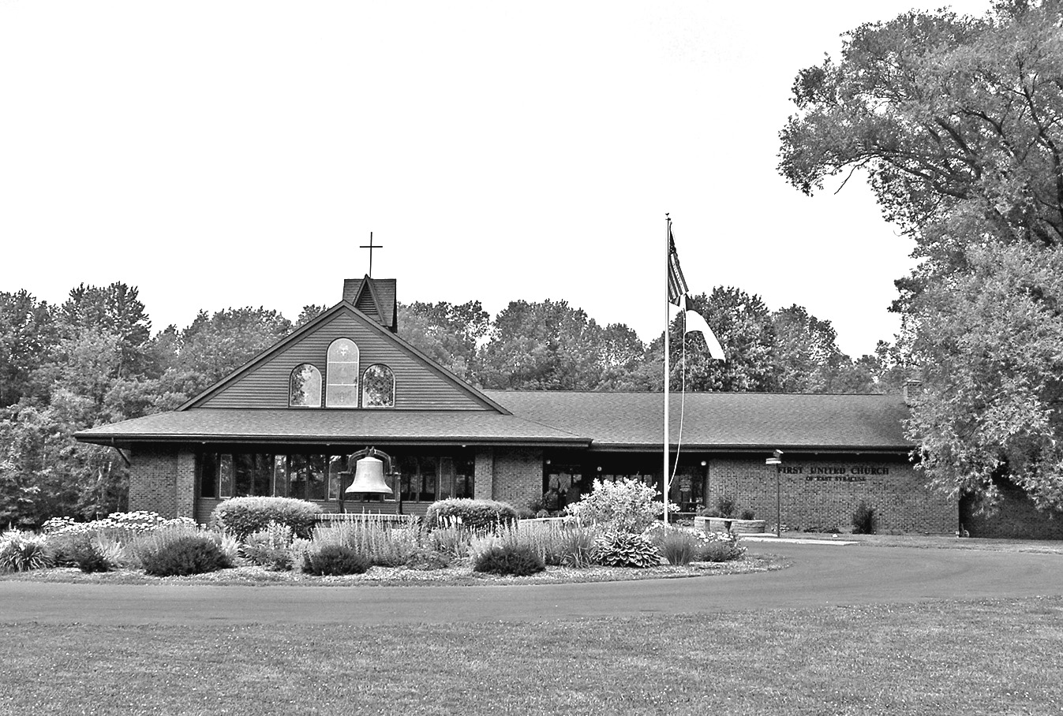

Third Sunday in Lent
March 22, 2020
10:00 A.M.

The First United Church of East Syracuse
823 Franklin Park Drive, East Syracuse, NY 13057
Affiliated with the United Methodist Church
and the Presbyterian Church (USA)
Rev. Debra L. Thomas, Pastor

